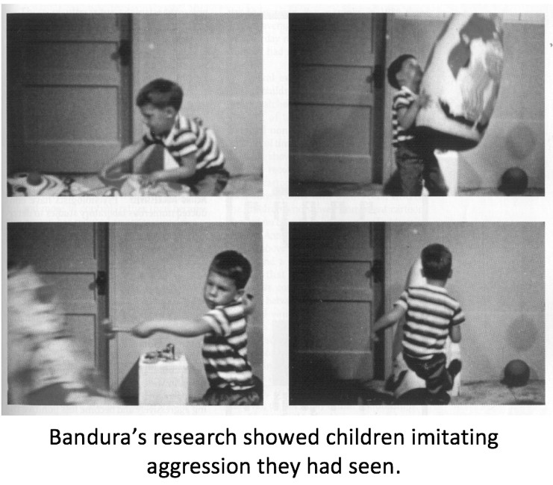Case Study: Bobo Doll

(Bandura, Ross and Ross 1961)

Sample Group:

Methodology/Procedure:

Results/findings:

Contributions to psychology/society:

Strengths:

Limitations: